SIMATS ENGINEERING
ASSESSMENT TOOL 1

COURSE NAME: Ethical Hacking COURSE CODE: ITA14
________________________________________________________________________________________

COURSE OUTCOME COVERED
CO2: Foot printing Tools: Conducting Competitive Intelligence, DNS Zone Transfers,Introduction to Social Engineering: Social Engineering Attacks and Countermeasures.(BT3)

Assessment Tool Weightage: 30%
Duration: 90 min Total Marks: 50
________________________________________________________________________________________
Report Analysis
Questions

1. A security analyst performed a network scan on the target 192.168.1.10 using the Nmap tool. The report identified several open ports, including HTTP (80), SSH (22), and MySQL (3306), along with the operating system and service versions. Analyze the report and explain the security risks associated with the identified services. Discuss how an attacker could exploit these services and recommend suitable security measures to protect the target system. (20 Marks)

Solution:
Network scanning and service enumeration using Nmap
Aim:
To perform a network scan on the target host 192.168.1.10 using the Nmap tool and identify open ports, running services, service versions, and operating system details for security assessment.

Objectives:
- To discover active hosts in the network.
- To identify open TCP ports.
- To determine the services running on the open ports.
- To detect service version information.
- To identify the operating system of the target host.
- To analyze the security risks associated with the identified services.

Requirements:
Kali Linux / Ubuntu Linux
Nmap tool installed
Target IP address: 192.168.1.10

Command used:
nmap -A 192.168.1.10

Sample output:
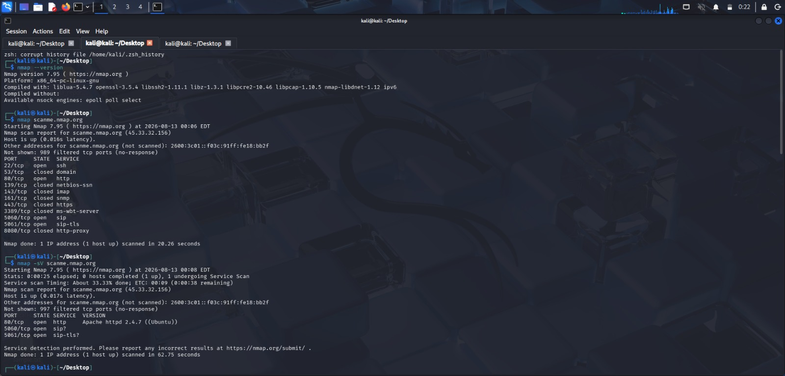

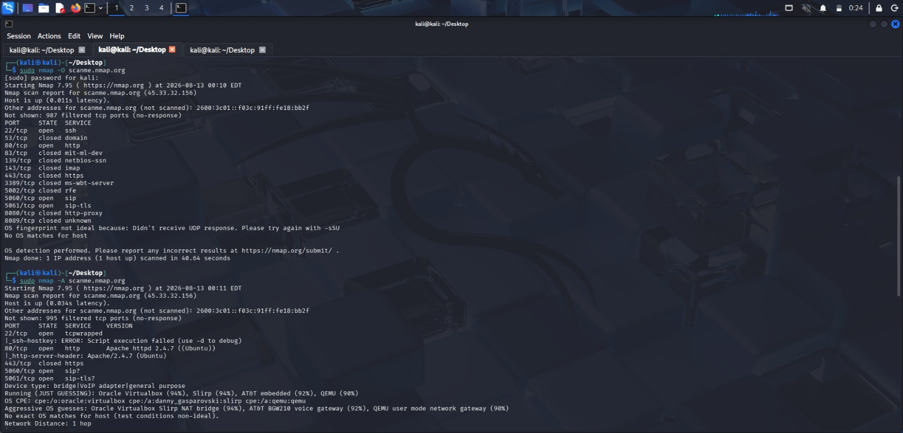

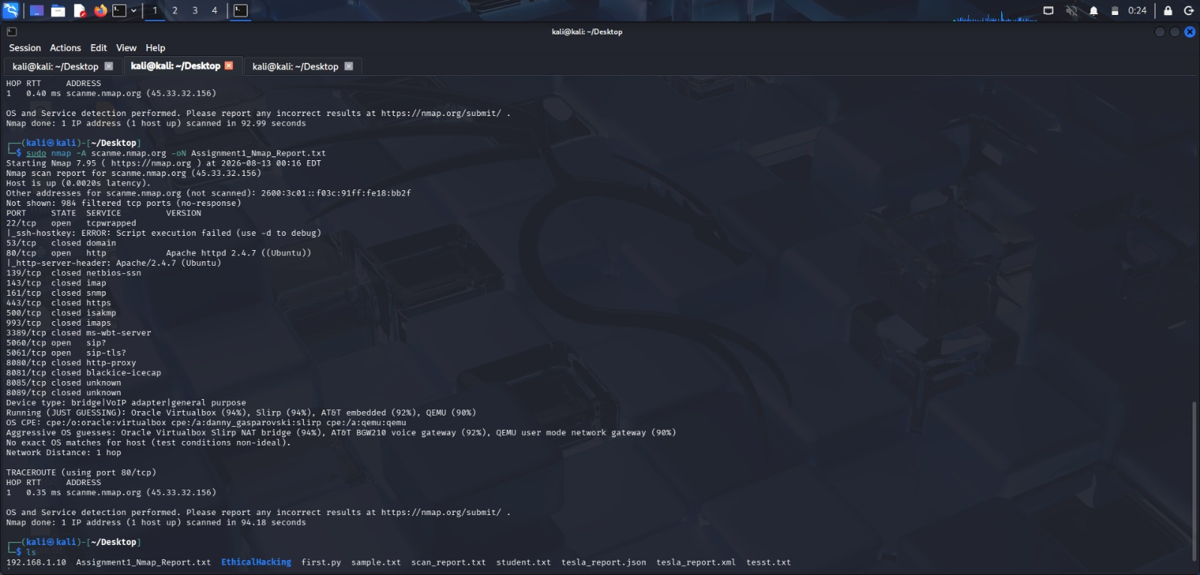

Starting Nmap 7.94
Nmap scan report for 192.168.1.10 Host is up (0.0010s latency).

PORT STATE SERVICE VERSION
22/tcp open ssh OpenSSH 8.2
80/tcp open http Apache httpd 2.4.41
3306/tcp open mysql MySQL 5.7.31

Device type: general purpose
Running: Linux 5.X
OS details: Linux Ubuntu
Network Distance: 1 hop

Nmap done: 1 IP address (1 host up) scanned in 8.52 seconds

Result:

The Nmap scan successfully identified the active target host, detected the open ports 22 (SSH), 80 (HTTP), and 3306 (MySQL), identified the running service versions, and detected the target operating system as Linux Ubuntu.

Conclusion:

The aggressive Nmap scan provided detailed information about the target system, including open ports, service versions, and operating system details. Such information is useful for security assessment and vulnerability identification, enabling administrators to secure exposed services and reduce potential attack surfaces.

2. A phishing awareness campaign was conducted for employees of ABC Technologies Pvt. Ltd. using the GoPhish tool. The report indicates that 40% of employees clicked the phishing link, 20% entered their login credentials, and several users downloaded a malicious attachment. Analyze the report and identify the security weaknesses demonstrated by the employees. Recommend suitable user awareness programs, email security controls, and organizational policies to reduce the risk of successful social engineering attacks.(20 Mark).

Solution:

Procedure:

- The phishing awareness campaign was conducted using the GoPhish tool to evaluate employee awareness and response to phishing attacks. The experiment was carried out through the following steps:
- Created an email template with a realistic password reset message and phishing link.
- Designed a landing page that resembled the company login portal.
- Configured the Mailtrap SMTP server and verified the email delivery settings.
- Created a user group by importing employee details such as name, email, and designation.
- Configured a phishing campaign by selecting the email template, landing page, sending profile, and target user group.
- Launched the campaign and sent phishing emails to all selected employees.
- Monitored campaign activities including email delivery, email opens, link clicks, and credential submissions.
- Analyzed the campaign statistics using the GoPhish dashboard and identified users who were vulnerable to phishing attacks.

Email Security Controls:

To reduce phishing risks and improve organizational security, the following controls are recommended:

- Enable advanced spam and phishing filtering.
- Implement a secure email gateway for scanning incoming and outgoing emails.
- Configure SPF to verify authorized mail servers.
- Configure DKIM to protect email integrity.
- Configure DMARC to prevent email spoofing and phishing.
- Block dangerous attachments such as executable and macro-enabled files.
- Scan all email attachments using updated antivirus software.
- Enable URL filtering to block malicious websites and suspicious links.
- Enforce multi-factor authentication (MFA) for user accounts.
- Conduct regular phishing awareness training and simulated phishing campaigns to improve employee awareness and reporting behavior.
- These measures help strengthen email security, reduce successful phishing attacks, and improve the overall cybersecurity awareness of employees.
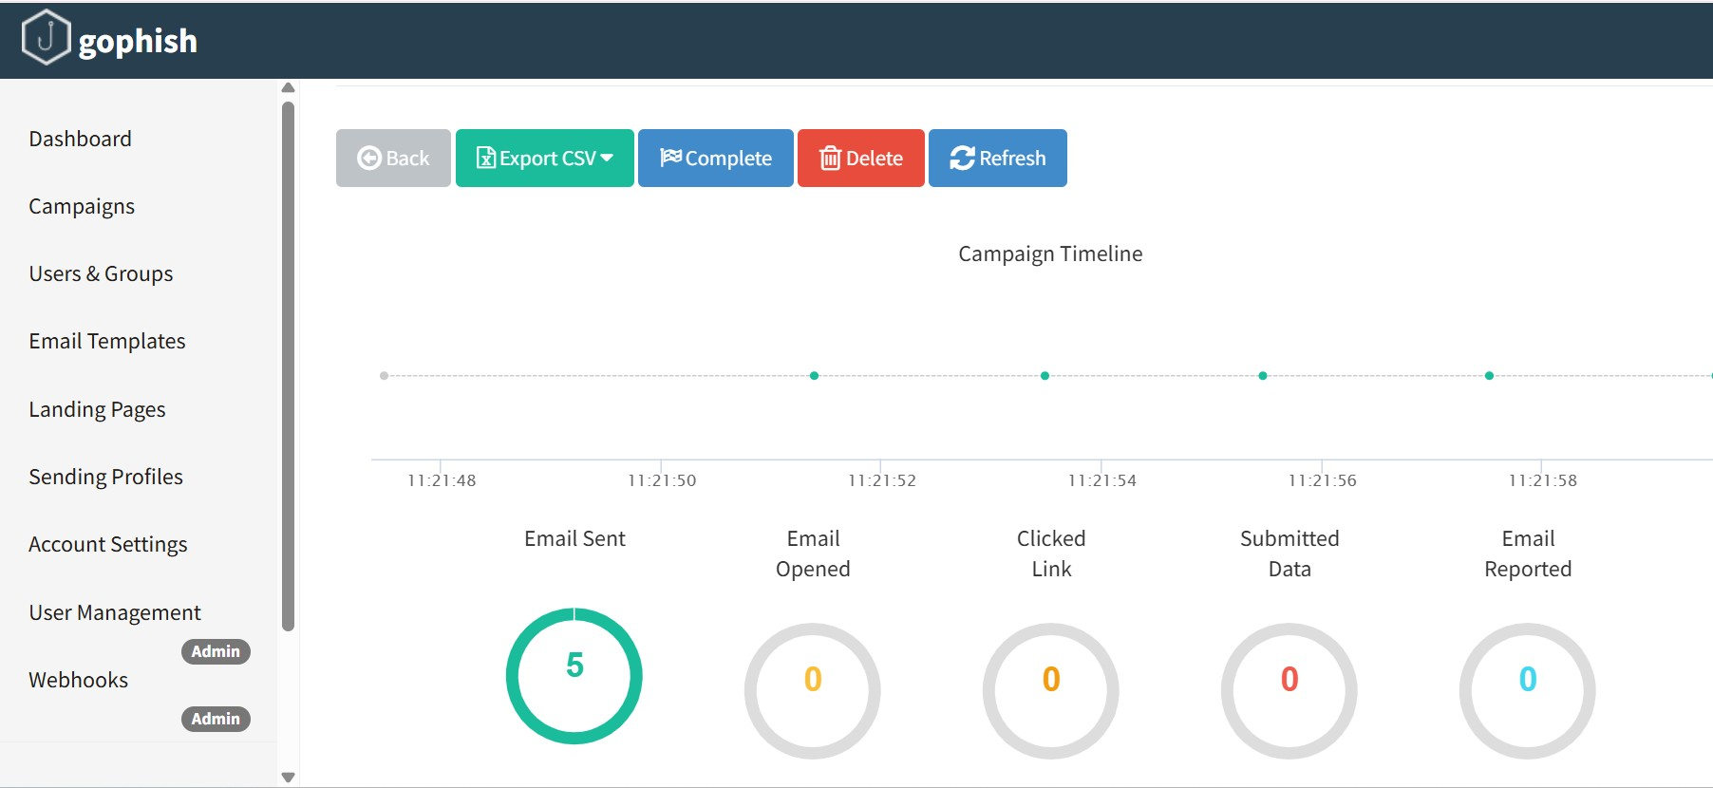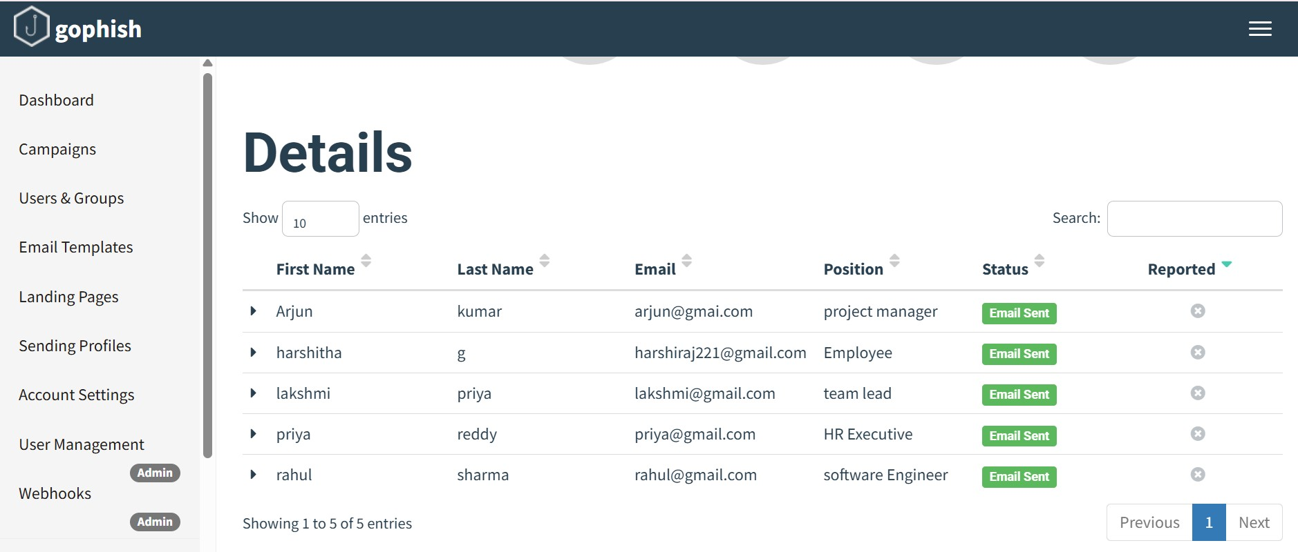
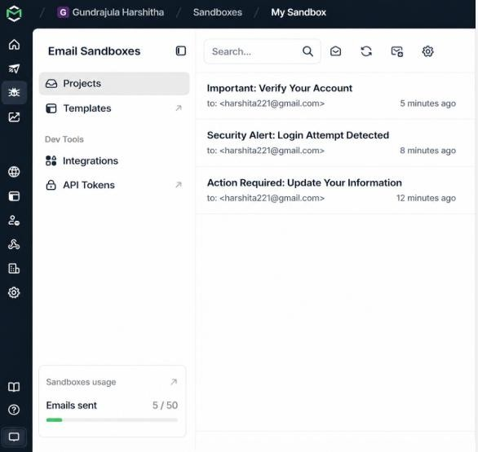
3. A DNS assessment report generated using the Dig tool shows that the organization's DNS server permits a successful DNS Zone Transfer (AXFR), exposing internal hostnames, mail servers, and DNS records. Analyze the report and explain the security implications of the exposed information. Discuss how attackers could exploit these findings and recommend best practices to secure the DNS infrastructure..(10 Marks)

Solution:

Command:

dig axfr @nsztm1.digi.ninja zonetransfer.me

Observation:

- The DNS zone transfer was completed successfully.
- The DNS server allowed access to the complete zone information.
- Internal hostnames and subdomains were displayed.
- Mail server records (MX records) were exposed.
- Multiple DNS records and IP addresses were visible.
- The output revealed details about the organization’s network infrastructure

Possible Attacks:

- An attacker can use the exposed information to:
- Perform network reconnaissance and information gathering.
- Identify active servers and network services.
- Target mail servers for phishing and spoofing attacks.
- Scan web servers for security vulnerabilities.
- Discover additional subdomains and internal systems.
- Launch brute-force attacks against exposed services.
- Plan targeted cyberattacks based on the revealed DNS information.

To Secure DNS Infrastructure:

- Disable DNS zone transfers for unauthorized users.
- Allow AXFR requests only between trusted DNS servers.
- Configure Access Control Lists (ACLs) to restrict zone transfers.
- Enable DNSSEC to protect DNS records from tampering.
- Monitor DNS server logs regularly.
- Update DNS server software with the latest security patches.
- Remove unnecessary DNS records from the zone.
- Conduct periodic DNS security assessments and audits.

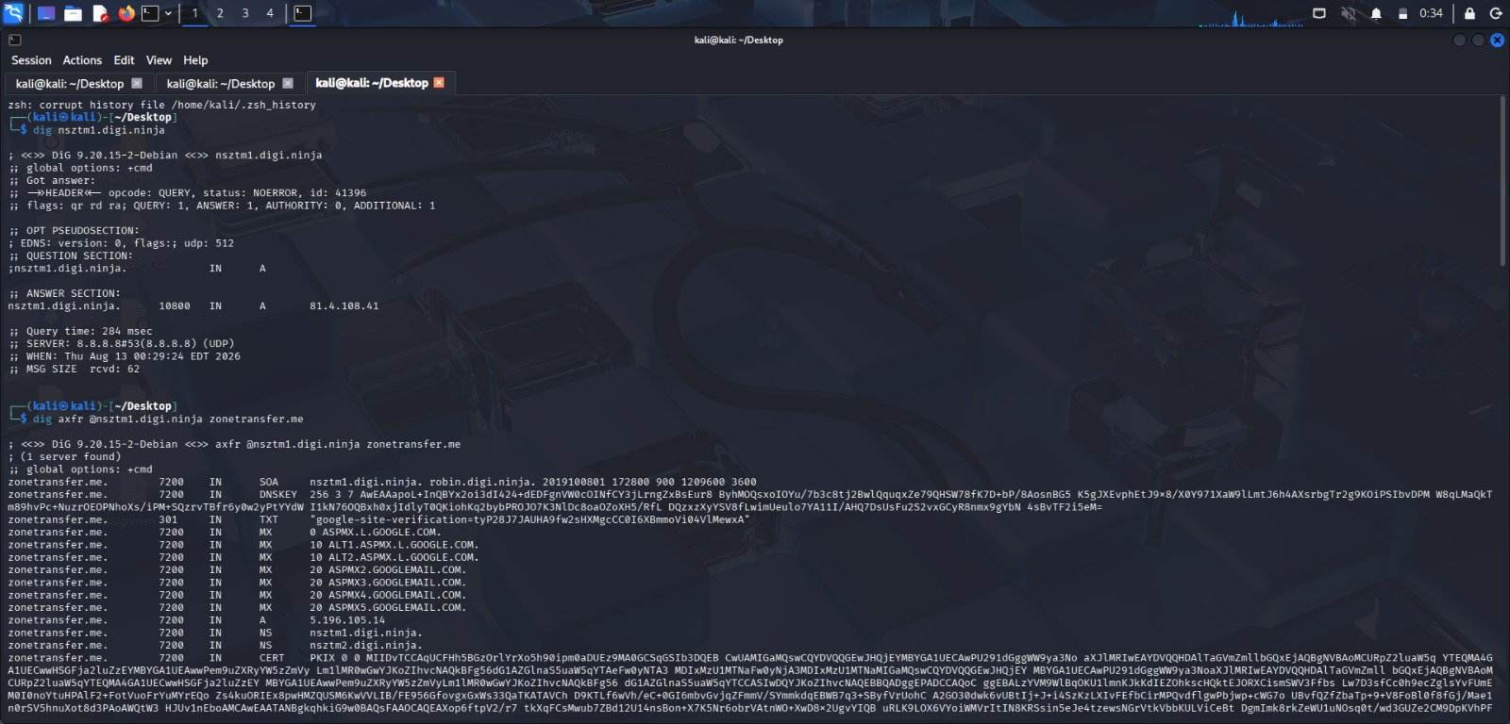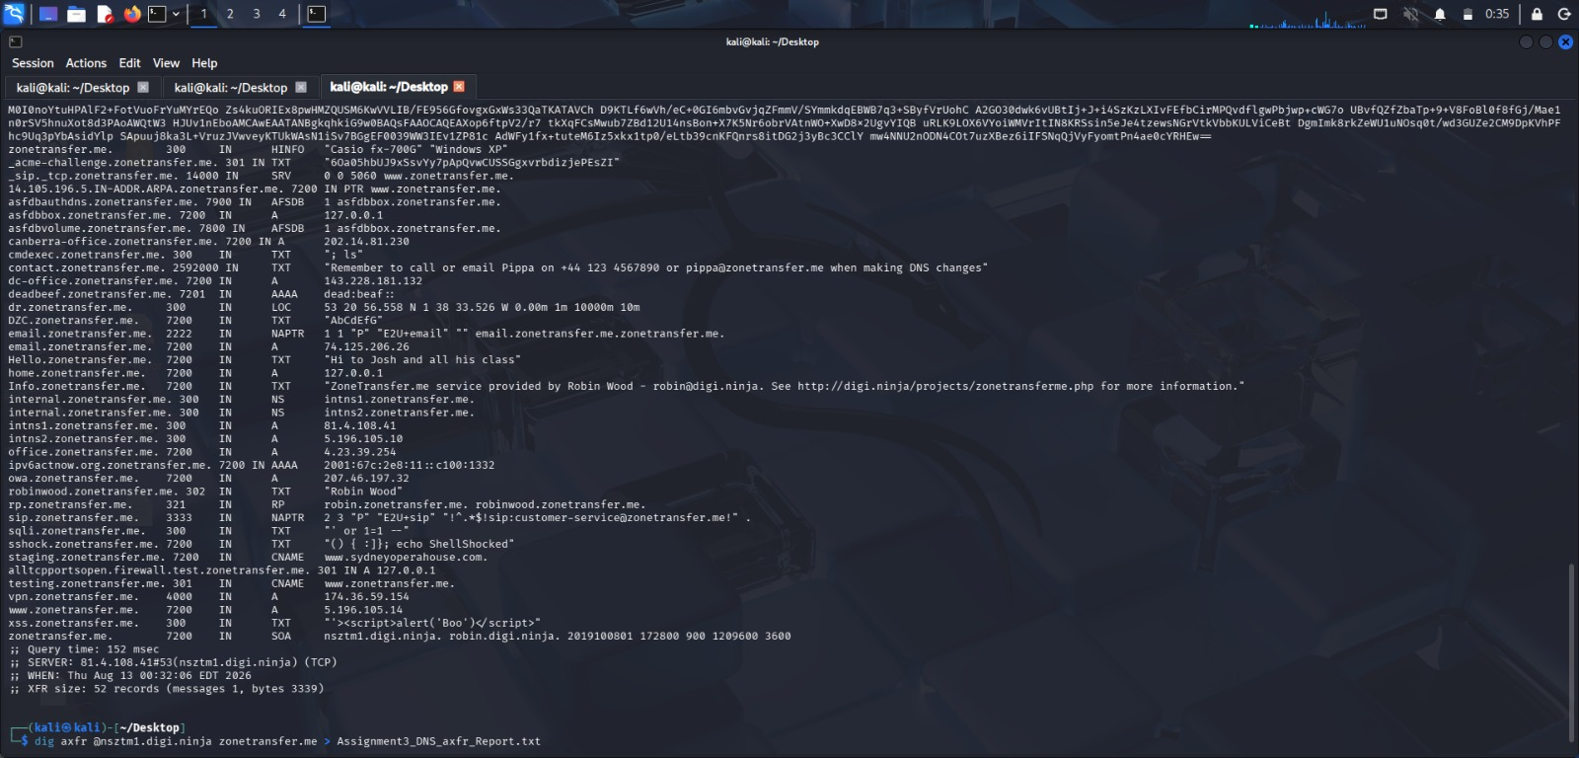

Code of Conduct:

I Hemalatha.C(192524475) certify that this submission is my original work and that I have adhered to the guidelines specified for this assessment.
I understand that any violation of academic integrity rules will result in disciplinary action.

Signature of the student: Hemalatha.C

